**PROJECT COMPLETION REPORT**

**1000 KG/HR FATTY ACID BEADS PLANT**

**LOCATION: VVF INDIA LTD, TALOJA**

**DATED: 10/10/2016**

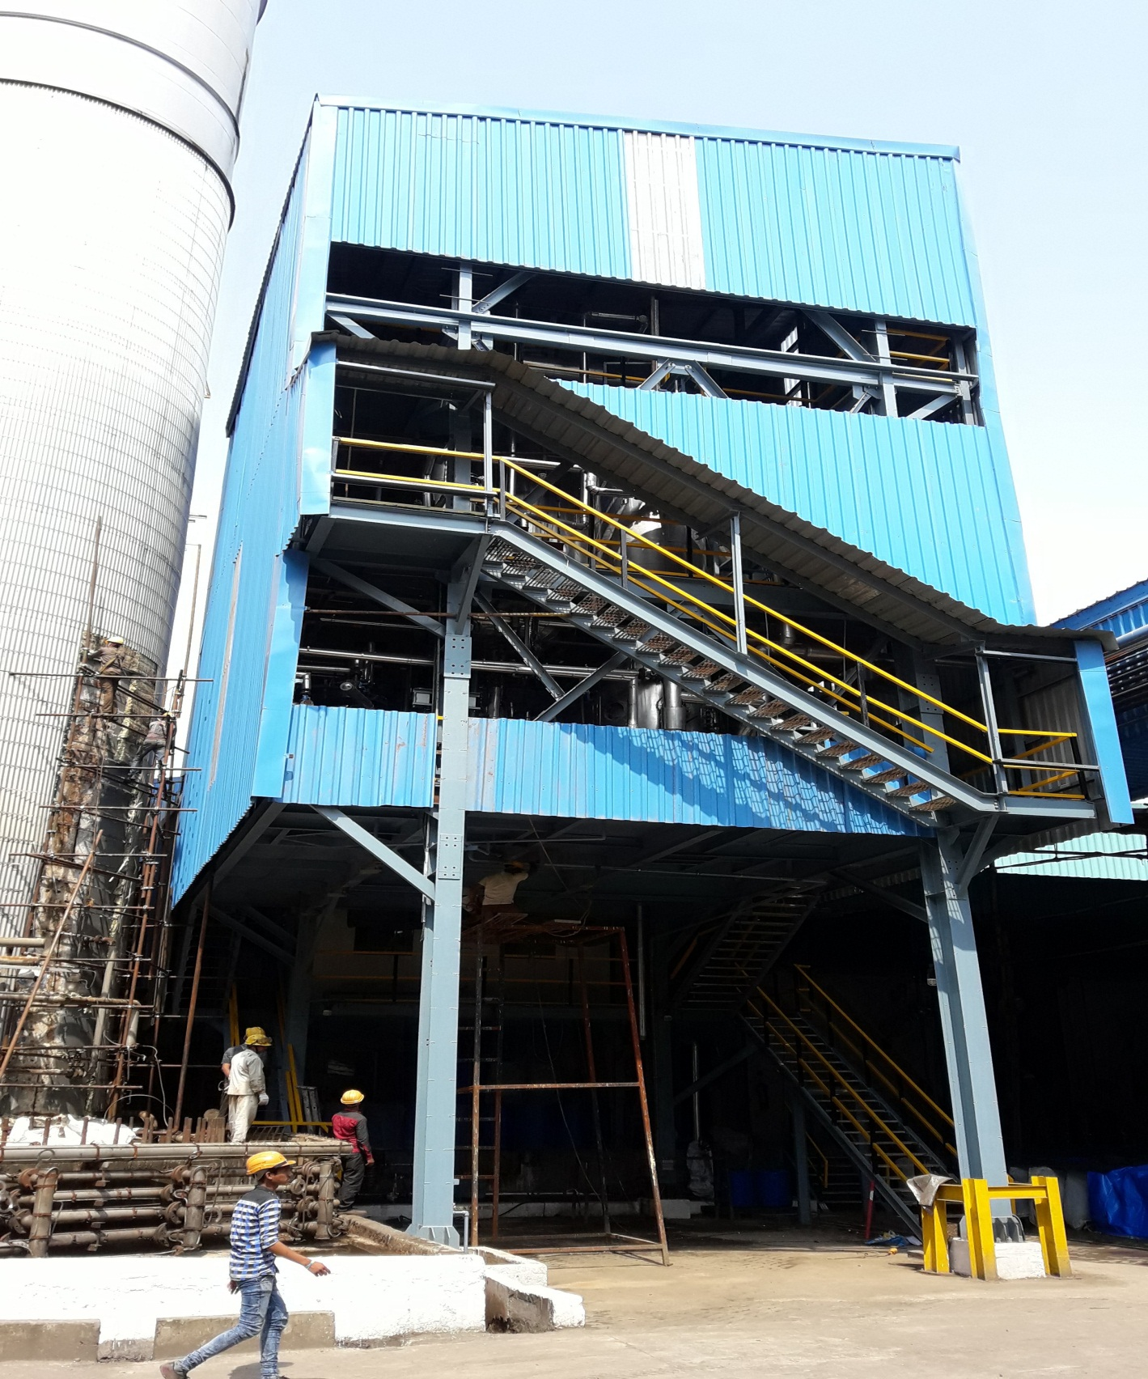

# PROJECT INFORMATION

|  |  |
| --- | --- |
|  | **Description** |
| **Project Name** | FATTY ACID BEADS PLANT |
| **Project Description** | 1000 Kg/Hr of Fatty Acid Beads Plant. |
| **Project Manager** | Mr. Pramath Sanghavi |
| **Project team Members** | Anandrao Sangle, Sandip Kundu, Govind Ghule, Sagar Panchal, Satish Jadhav, Rohidas Ninawe, Amit Londhe, Gopal Krishna Sawant, Ravi Sonkamble, Milind Patil, Mahesh Hindlekar, Santosh Sharma, Joseph Sathe, |
| **Supporting team Members** | Dinesh Danav, Ajay Kumbhar, Pravin Patil, Sunil Katekari, Pravin Nerkar, Suryakanth Shabolu, Pratik Mehta, Rayomand Mirzan |
| **Project approved on** | 01.02.2016 |

|  |  |  |  |  |
| --- | --- | --- | --- | --- |
|  | **Baseline** | **Actual** | **Variance** | **% Variance** |
| **Start Date** | 01.02.2016 | 01.02.2016 | 0 | 0 |
| **Finish Date** | 31.08.2016 | 24.09.2016 – 1st Run  26.09.2016 – 2nd Run | 24 days | 14% |
| **Months** | 07 | 08 | 1 month | 14% |

# PROJECT OBJECTIVE:

AT VVF Taloja Plant, Currently C16 & C18 fatty acids are produced in the form of flakes. However, there is limited demand for these materials in flakes form. As explored by the VVF Marketing wing, the demand for the same product is substantial if it is supplied in beads form. The area of the beads demand is animal feed.

This was an initiating point of the fatty acid beads project.

The project objective is to install a fatty acid beads manufacturing facility to produce fatty acid beads (C16/C18) at 1000kg/hr capacity maintaining desired quality & particle size distribution.

The project management objectives were to select technology & vendors followed by installation & commissioning of the fatty Acid Beads plant within given budget, timelines and allocated space approved by the management.

# MANAGEMENT EFFECTIVENESS:

Project Management had taken challenge to complete by 07 months instead of 09 months to get the maximum benefit by taking major actions for following function from beginning of the project:

* Making micro schedule of all activities
* Forming team and distributed all roles among the team members
* Layout, PID & engineering was done in-house which saved on outsourcing of these activities
* Some of the non-core team members of project team deputed on a specific role to expedite project execution and also improve quality & effectiveness of project execution. For example
  + Santosh Sharma deputed for insulation job supervision
  + Mahesh Hindlekar was incorporated for measurements, testing & cardboard blasting
* Respective team members executed a lead role to finalize vendor by involving/ participating vendor technical evaluation, technical estimation, costing, approving technical specification, commercial contract draft write up etc.
* Technological innovations and economical design approval
* Overall plant layout approval within the available space.
* TPI inspection of each item of vendor design within time allotted in order to ensure quality of items
* Expediting the vendor work by deputing engineering resources and taking early decisions
* Effective coordination with technology supplier for expediting delivery and reduce delay on project timelines

**As result of above, the plant has been commissioned within 8 months of capex approval date.**

# challenges FACED:

Some of the challenges faced during project execution and commissioning

* **Delay in delivery of equipment by M/s TTPL** 
  + As per PO, TTPL was to deliver the plant equipment in lots starting from 24.06.2016 till 18.07.2016. VVF project team started visiting site from 17.06.2016 for delivery follow up and updated about the likely delay against the committed delivery schedule. On 14.07.2016, VVF project team again visited and found that the delivery is further getting delayed.
  + As discussed with TTPL on 14.07.2016 during review progress & expedite work, VVF arranged for additional skilled resources at TTPL works from M/s Sidditech. This helped in reducing the further delay of 2 weeks in delivery of the first lot.
  + As a result TTPL delivered the equipment and materials between 25.07.2016 and 30.08.2016. Thus, total effective delay in delivery is 6 weeks
  + To reduce the delay in project timelines, project team closely coordinated with contractor and completed all installations by 02.09.2016. There was a reduction of delay in project execution by 2 weeks. Thus delay in TTPL equipment delivery of 6 weeks to gather with resources arrangement and efficient execution reduced the effective delay by 2 weeks.
  + Thus with mechanical completion the plant was ready for commissioning from 03.09.2016. VVF called TTPL engineers from 29.08.2016 for initiating the pre-commissioning activities. However, they did not turn up.
* **Delay in commissioning of equipment by M/s TTPL**
  + From 03/09/2016 to 16/09/2016 M/s TTPL did not send commissioning engineer at site for the want of the payment release despite of incomplete supply of feed piping & connector for spray nozzle.
  + TTPL started pre-commissioning activities from 17.09.2016 and completed commissioning on 24.09.2016. Thus, the efforts made to expedite delivery and execution could not be benefitted in terms of production gain.
* **Challenge to VVF projects due to new product**
  + Major challenges were to select proper specification of technology, equipment & instruments which were met out with skills and innovation
* **Challenge to VVF projects due to new proprietary equipment**
  + Being a new technology, most of the equipment related to beads plant was new for VVF. Hence, for the purpose of ensuring quality supply of the equipment of new technology, TUV NORD was engaged as a TPI for approving QAP, inspected thoroughly stage wise (quality of procurement, fabrication & testing of equipment / system).

# administrative closure:

The project is completed with 72 hrs full load trial on 06.10.2016.

Below is major milestones achieved.

* Pre-commissioning activity from 19.09.2016 to 23.09.2016
* Plant first run on 24.09.2016 – 1.5hrs
* Plant second run on 26.09.2016 - 5 hrs
* 72 Hrs PGR started from 29.09.2016 & stopped on 30.09.2016 – 26hrs completed
* Remaining 72hrs PGR completed from 04.10.2016 to06.10.2016 – 48hrs.
* M/s TTPL engineers left site on 07.10.2016 after signing off the MOM.

The administrative closure of the project is being done with submission of project & relevant documents to Mr. Ajay Kumbhar (fatty acid plant, Taloja) & Mr. Aniruddha Bansod (regarding maintenance documents).

These documents are:

* Piping & Equipment (TTPL & VVF scope) including QC dossier
* All piping system loop file including flushing and pneumatic test report
* Equipment protocol file
* Supports details (primary, secondary and spring if any)
* As built isometric
* As built PID, As built equipment layout
* Equipment GA drawing and process data sheet
* IRN/ MTC report file of Piping Material/ equipment/ special items
* All approved QAP/ ITP/ procedures of materials and constructions.
* PQR/ WPS/ WQR and welder ID record file
* Instrument and Electrical (TTPL & VVF scope)
* Datasheet of all instruments/ Electricals items.
* Calibration report of instruments/ Electrical items
* Test & Guarantee certificate.---For all instruments/ Electrical items
* Updated PLC interconnection schedule----(As build)
* Updated logic description
* All alarm/tripping set point data/details of instruments
* Manual, Technical catalogue of Instruments/ Electrical items
* Updated instrument and Electrical index.
* QA/QC reports and MTC if any.
* Cable schedule
* Civil
* MTC of material
* Civil/ Structural engineering drawings
* As built plant layout
* Painting compliances report
* Concrete test reports